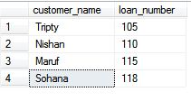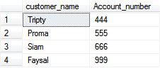

**Depositor**

**Borrower**

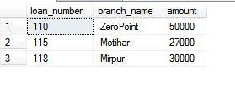

**Loan**

1. **Find all customers who have a loan or an account or both.**

**2. Find all customers who have an account but no loan.**

**3. Find all customers who have both a loan and an account.**

**4. Using join operation, find the customer name, loan number and loan amount of customers where the amount < 28,000**

|  |  |  |
| --- | --- | --- |
| **Branch_Name** | **Branch_city** | **Assests** |
| Dhanmondi | Dhaka | **20,000** |
| Banani | Dhaka | **40,000** |
| Sapahar | Naogaon | **50,000** |
| Jhautola | Cumilla | **5000** |
| Dhanmondi | Dhaka | **10,000** |

**TableName: Branch**

**5. Using sub query, find the names of all branches that have greater assets than all branches located in Dhanmondi**.

6. **Give 10% and 5% interest of those assests where branch_name is Dhanmondi and Banani and otherwise give 2% interest of other assests. [Solve this problem using one update statement]**